**NAME: Gaurav Kumar uid: 22BCS13192 Sec- 605(B)**

1. **Binary Tree Inorder Traversal**

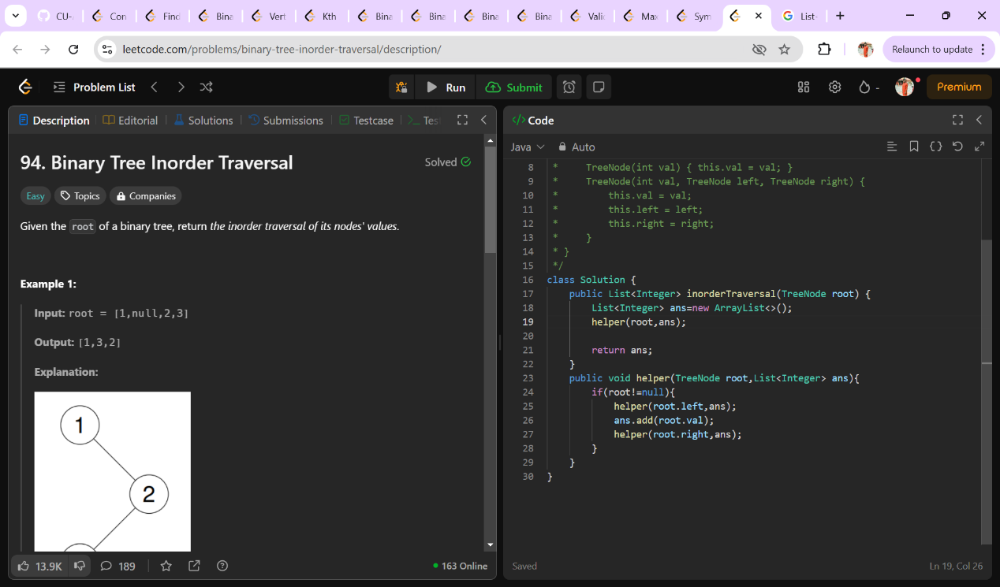

1. **Symmetric Tree**

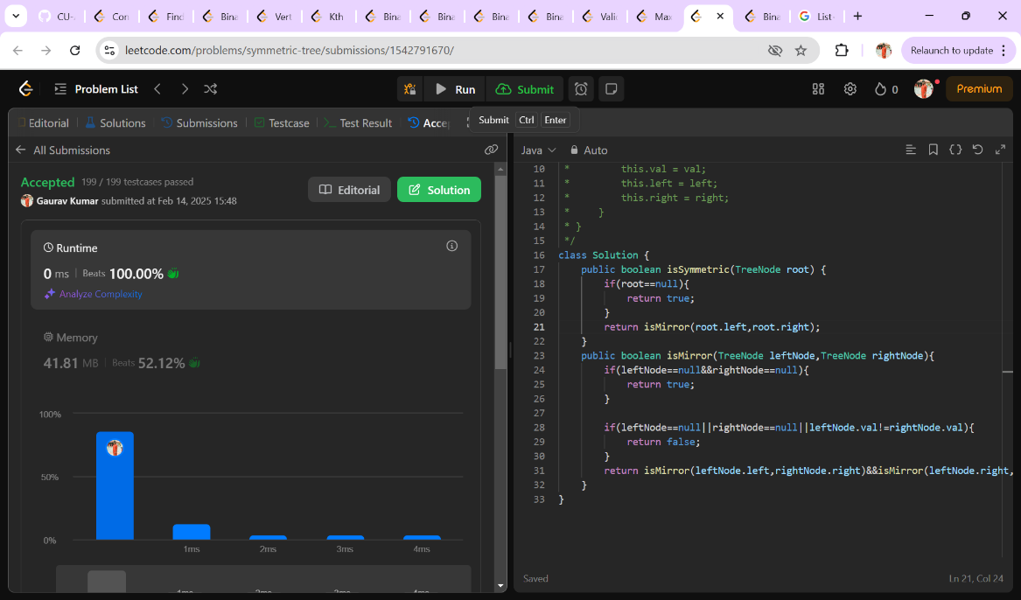

1. **Maximum Depth of binary tree**

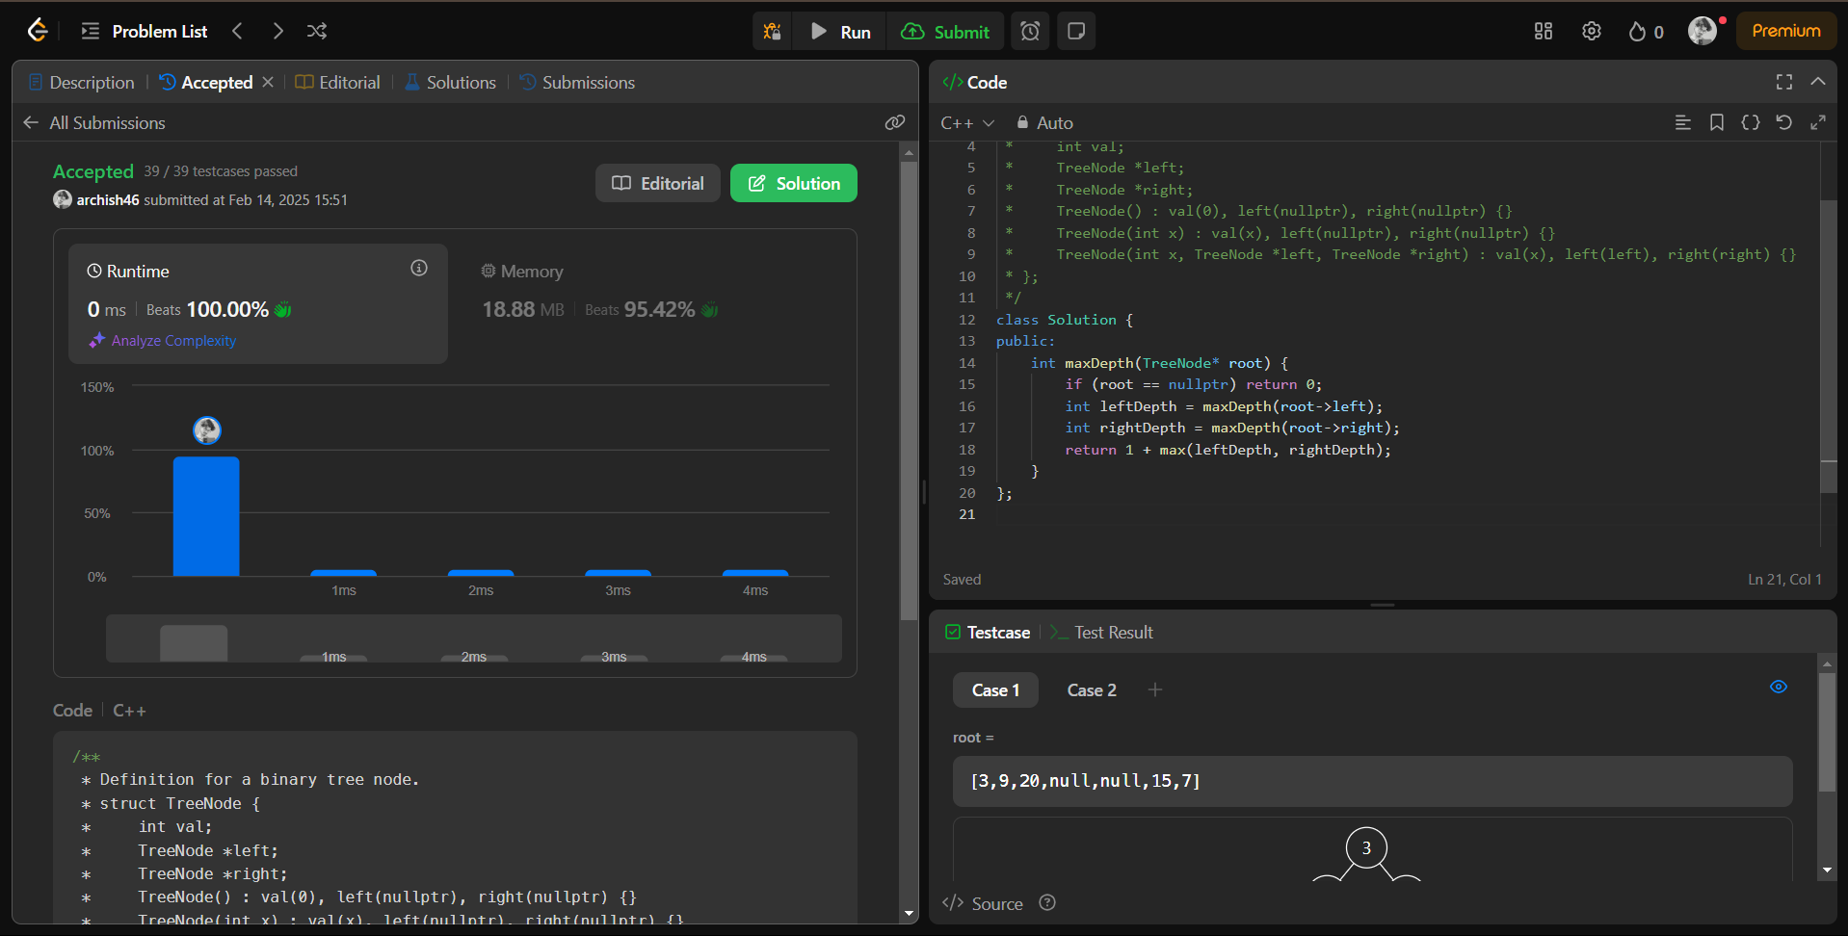

1. **Validate binary search tree**

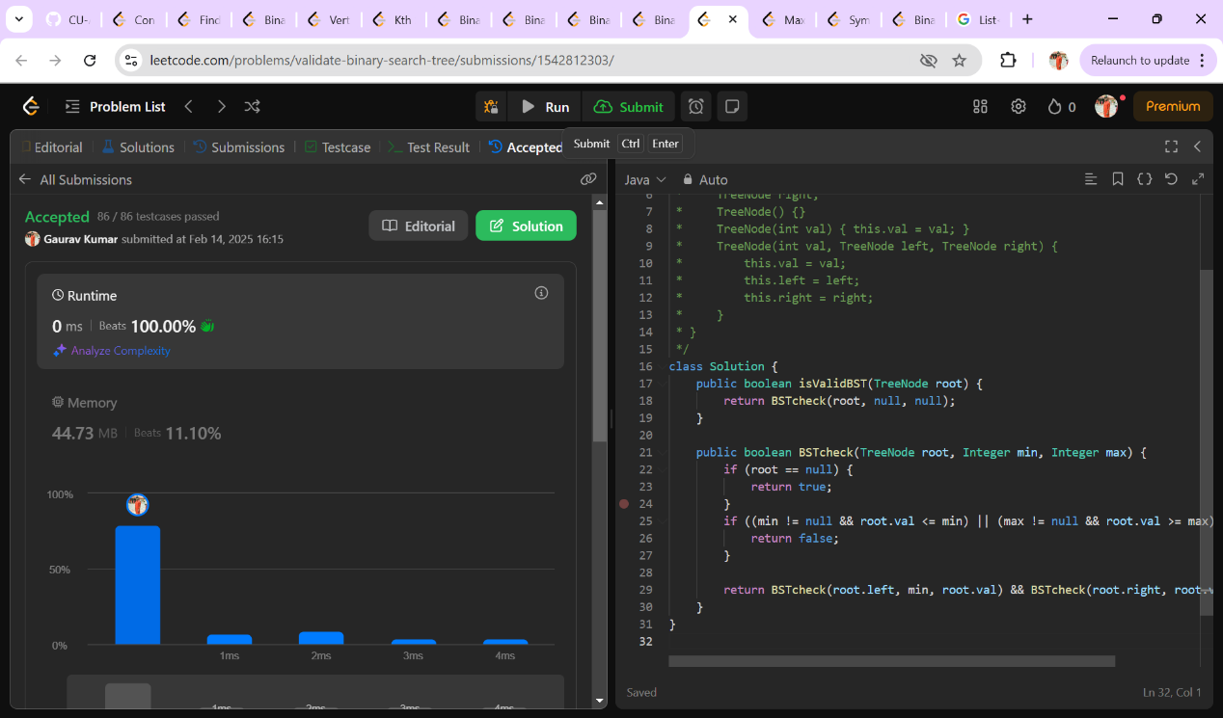

1. [**Kth Smallest Element in a BST**](https://leetcode.com/problems/kth-smallest-element-in-a-bst/)

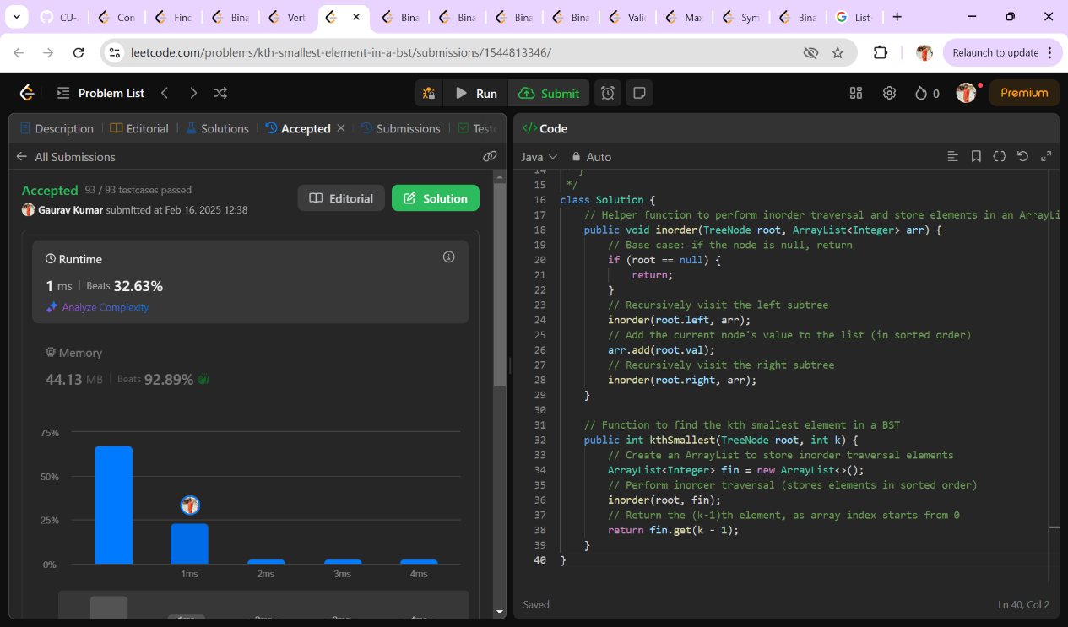

1. [**Binary Tree Level Order Traversal**](https://leetcode.com/problems/binary-tree-level-order-traversal/)

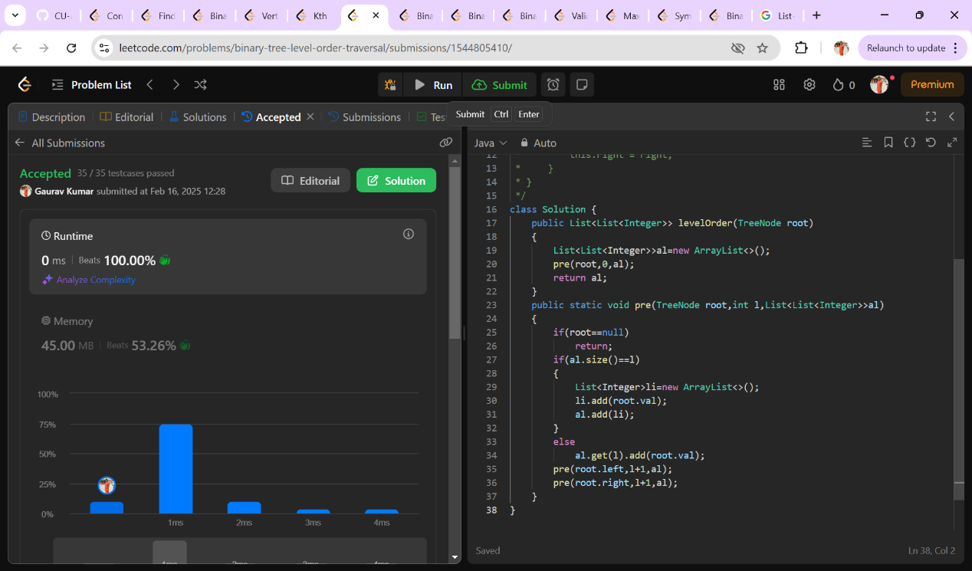

1. [**Binary Tree Level Order Traversal II**](https://leetcode.com/problems/binary-tree-level-order-traversal-ii/)

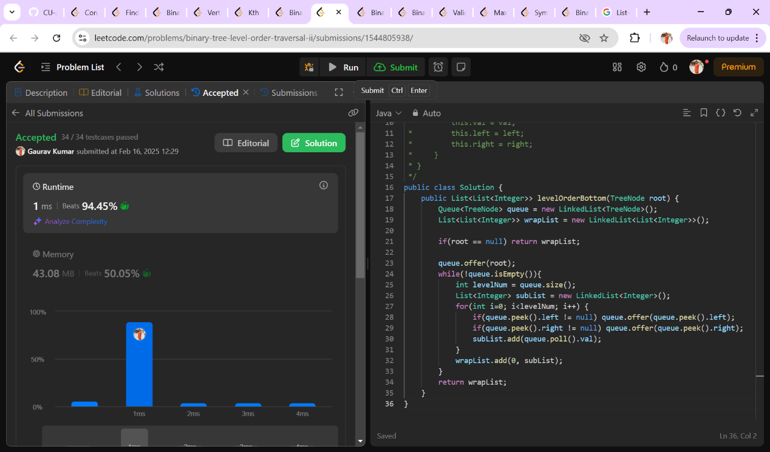

1. **Binary tree zigzag level order traversal**

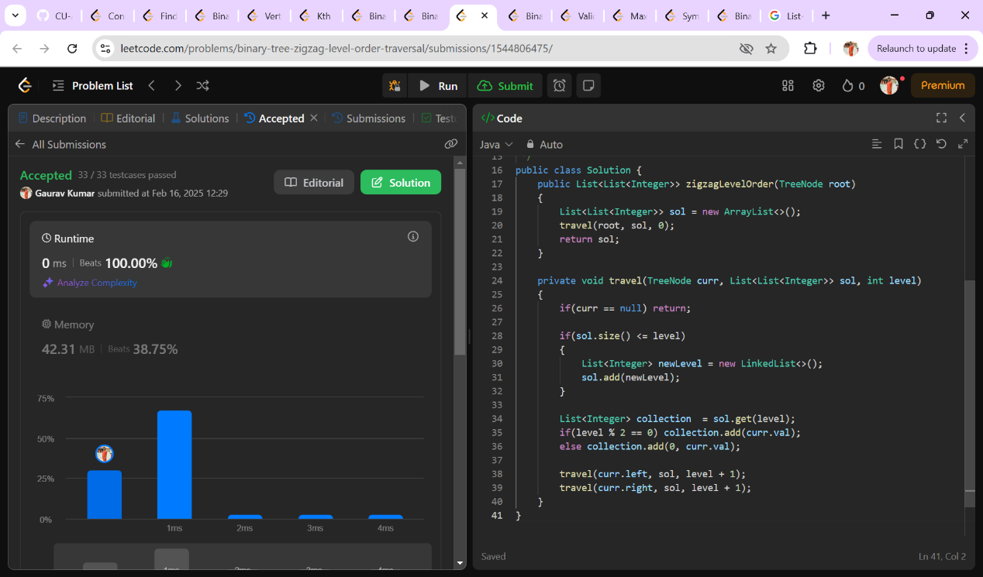

1. **Binary Tree Right Side View**

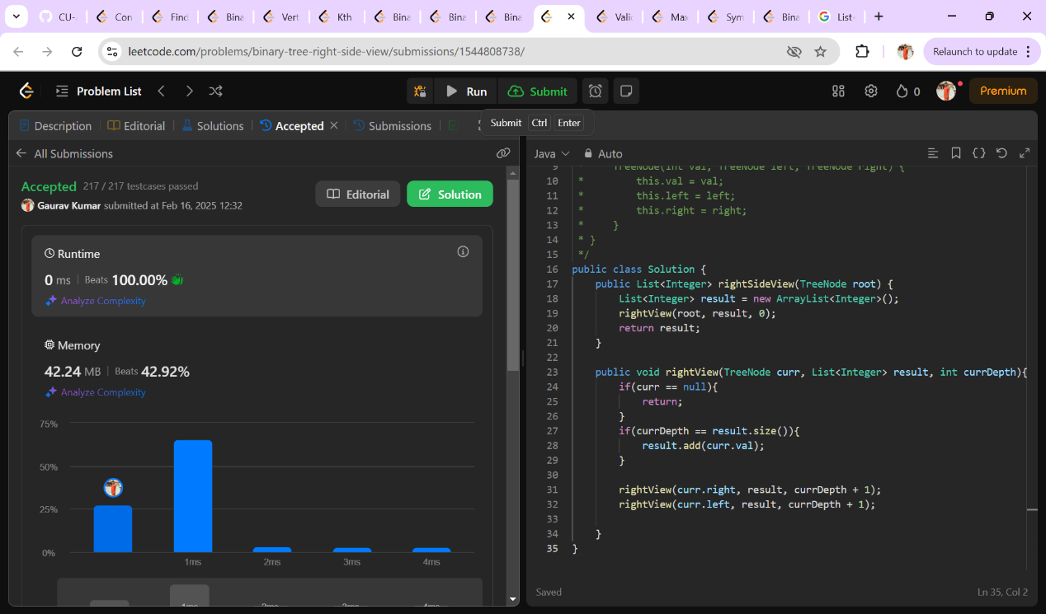

1. **Construct binary tree from inorder and post order traversal**

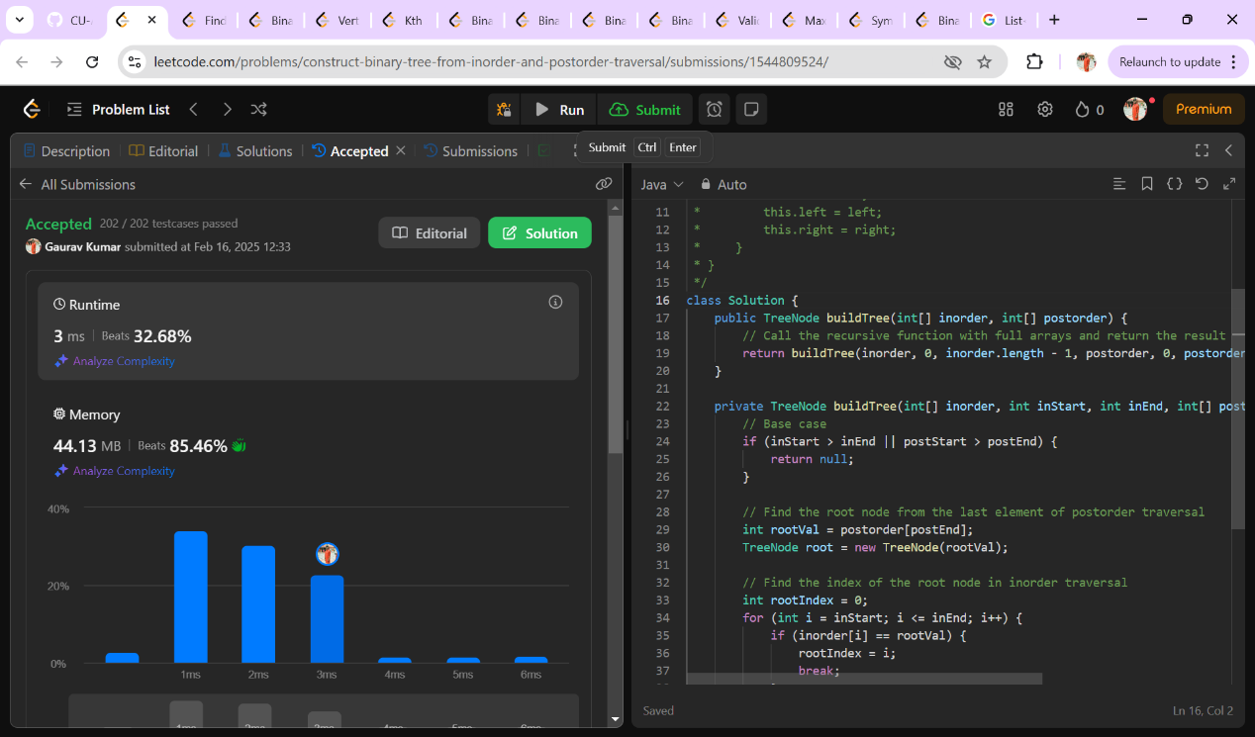

1. **Find Bottom Left Tree Value**

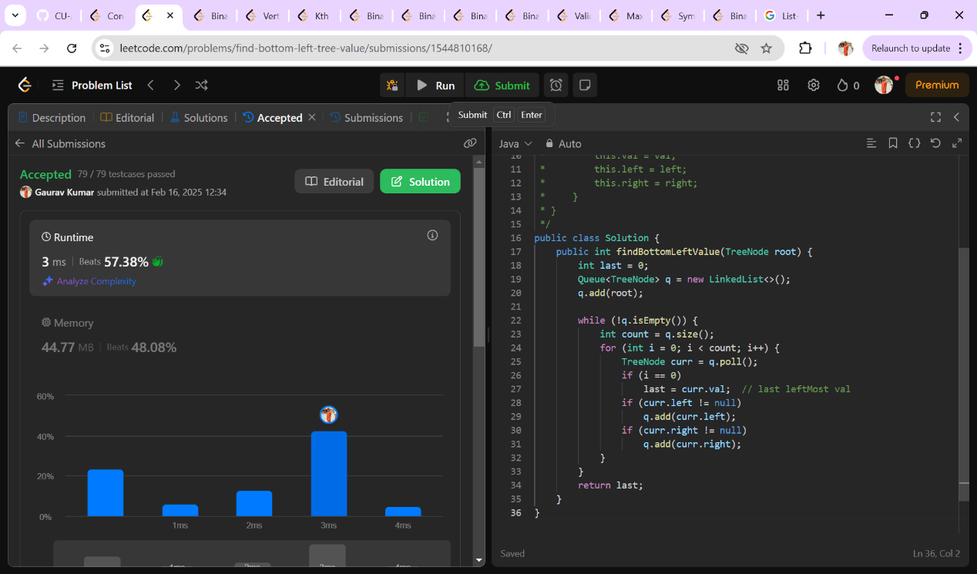

1. **Binary Tree Maximum Path Sum**

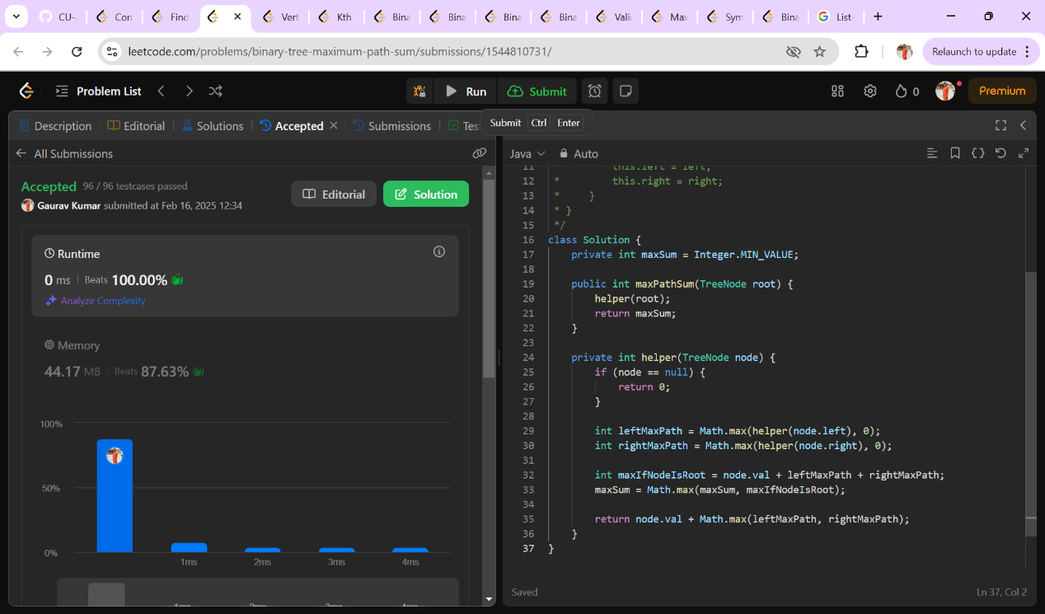

1. **Vertical Order Traversal of a Binary Tree**

